## https://lh4.googleusercontent.com/RuUC68UKRGyl4sAKxq_LDPCQPB9p0NNWN3YYWcNytHnWOO1KYachG-BU06_Q_DcGIbcGBpiC5NTlIvPP37L5c9lpOCN2hQ7SYJs8zQNqBXGOkwX4o8e6tsjdLIu225KDoJQY18VbcoBtSdyLWw·

https://lh5.googleusercontent.com/ubJvbGjbyPhGHhoicvVIBr8sz7F_2hV6yKYa-12C_zhp795HFbcPIZH0cp5sTLRTH4io7DwSKrk2j5U2hTTyroq6WdrehS0PvllfHK-HR4gG-3t-4THX55ULoTprZOv3sT0_QsGZgNNeeHeZ_w

**Group Number**: **9**

**Group Members Names**  
Muhammad Fahad                     l15-4379

Muhammad Zubair                     l15-4034  
Taimoor Mirza             l14-4520  
Muhammad Jamal Butt             l15-4255  
Abdul Rafey Tahir      l14-4014

# **Test Case 1:**

|  |  |
| --- | --- |
| Identifier | TC-1 |
| Priority | High |
| Short description | User will be able to add his/her Room/House as a Nook property |
| Pre-condition(s) | User has filled all the input fields |
| Input data | Input Strings , Images, Location |
| Expected result(s) | Property will add Successfully |
| Post-condition(s) | Property will appear on map |



# **Test case 2:**

·

|  |  |
| --- | --- |
| Identifier | TC-2 |
| Priority | High |
| Short description | This test case is written to check that whether map updated to new location or not, as this is last step before end of function. |
| Pre-condition(s) | Search bar in Focus |
| Input data | Fast Nuces Lahore |
| Expected result(s) | Map setting its location to geo coordinates(Latitude and Longitude of Fast) |
| Post-condition(s) | Map has been set to new updated location |

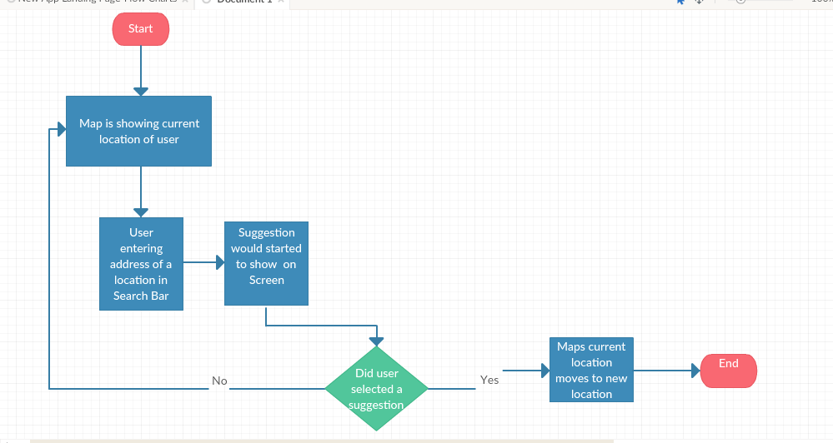

# **Test case 3:**

|  |  |
| --- | --- |
| Identifier | TC-3 |
| Priority | High |
| Short description | User books a Nook |
| Pre-condition(s) | BottomSheet is opened |
| Input data | UserID, PropertyID/NookID |
| Expected result(s) | User gets success notification of booking |
| Post-condition(s) | New booking will be listed in the MyBooking Section |

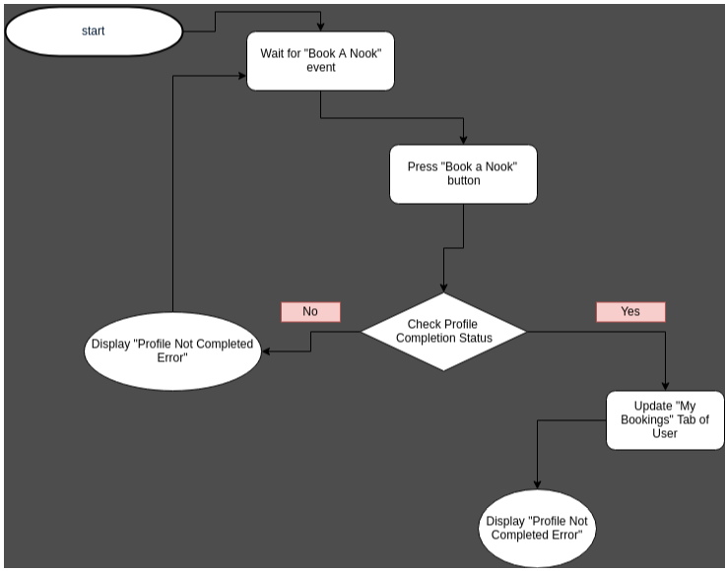

# **Test case 4:**

|  |  |
| --- | --- |
| Identifier | TC-4 |
| Priority | High |
| Short description | App will request user to allow location permission to get the users current location to show it on map |
| Pre-condition(s) | Location Permission Granted |
| Input data | Access Granted/Access Denied |
| Expected result(s) | User will Allow Location Permission and User’s Current location will be shown on Map |
| Post-condition(s) | Map will remember User’s Location and Highlight it using indicator. |



# **Test case 5:**

|  |  |
| --- | --- |
| Identifier | TC-5 |
| Priority | High |
| Short description | User will be able to See all its Bookings |
| Pre-condition(s) | User Must have at least One booking |
| Input data | User id |
| Expected result(s) | All Bookings against requested User id will be shown in the form of list. |
| Post-condition(s) | User will be able to perform Further Action(To view the booking property by clicking on the respective list item.) |

